**S3 (Simple Storage Service) 20th Aug 2024**

**Normal bucket create –**

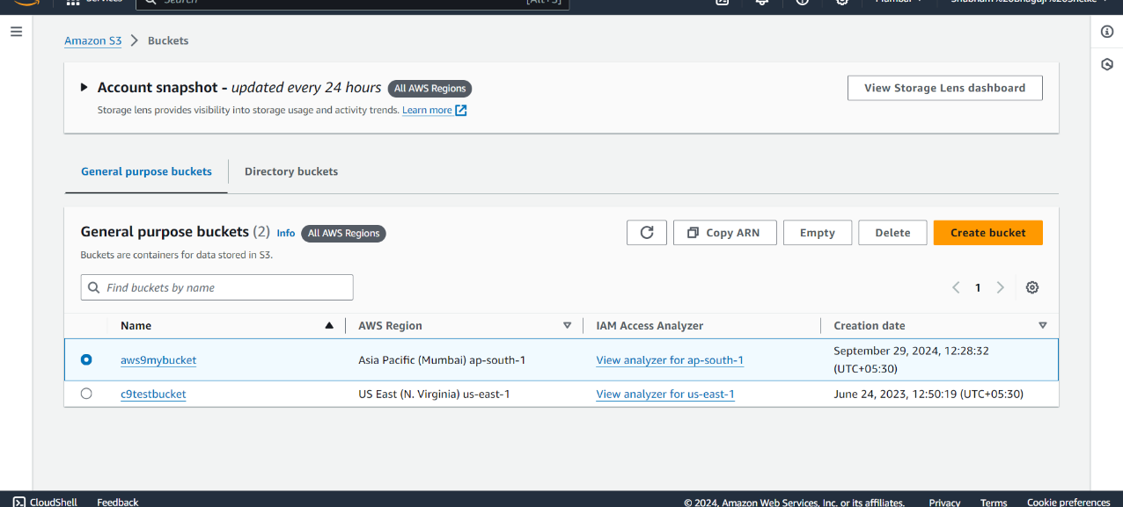

**Upload object in bucket –**

Private object

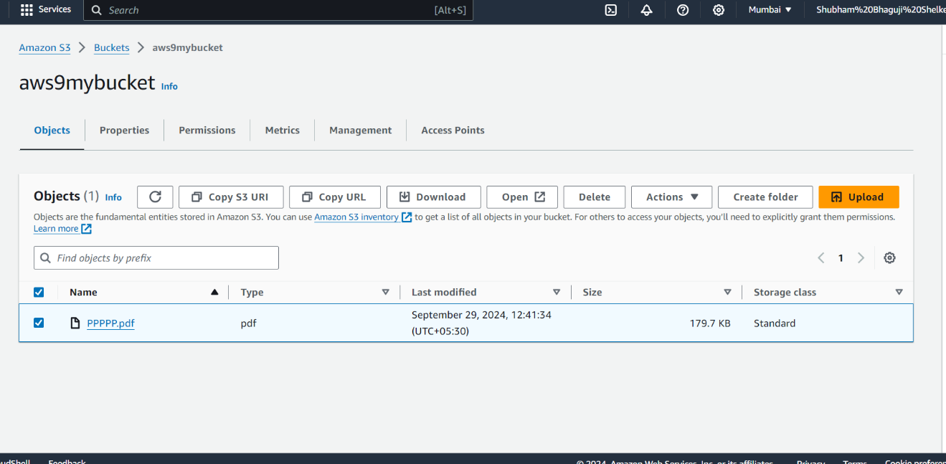

**Making public Object –**

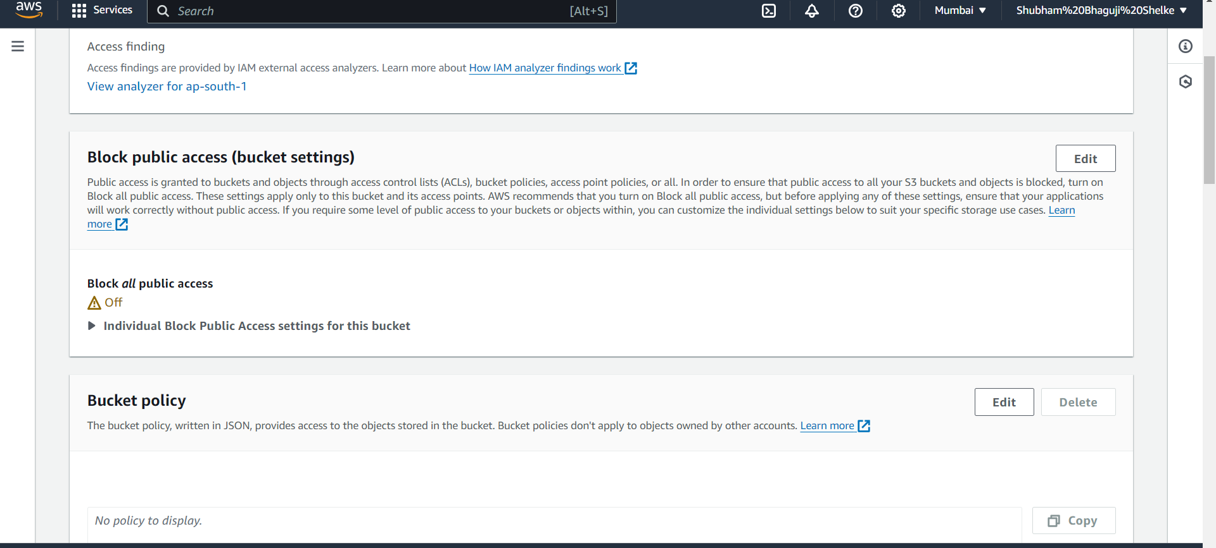

**Create life cycle policy –**

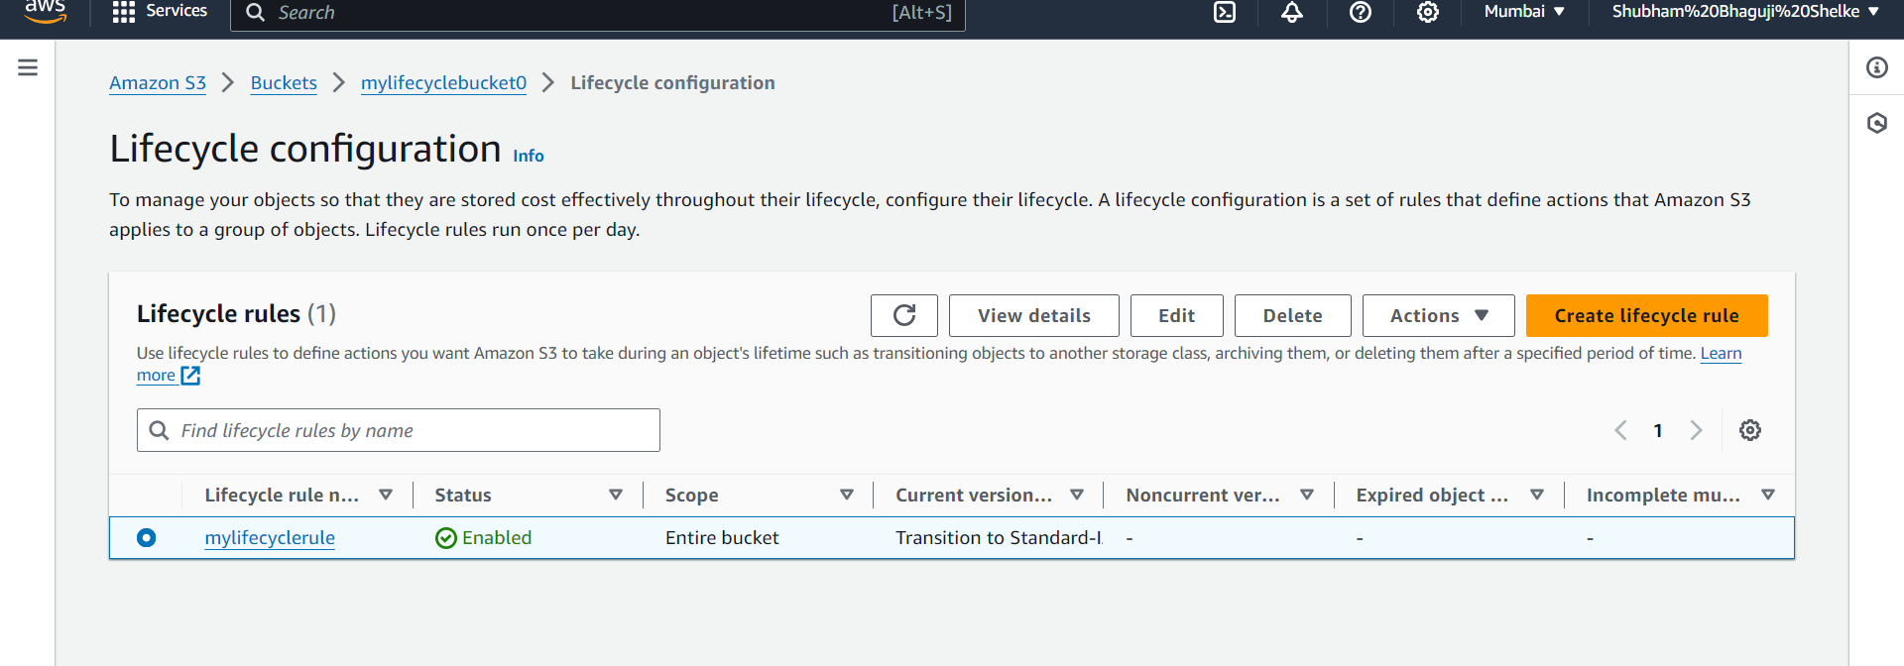

**Bucket versioning**

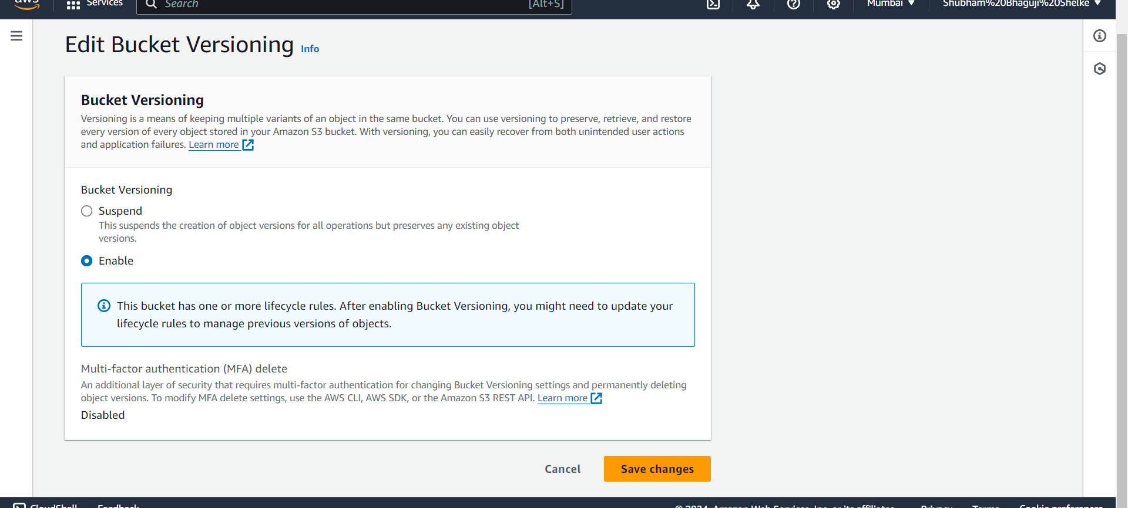

**Cross region replication (CRR) –**

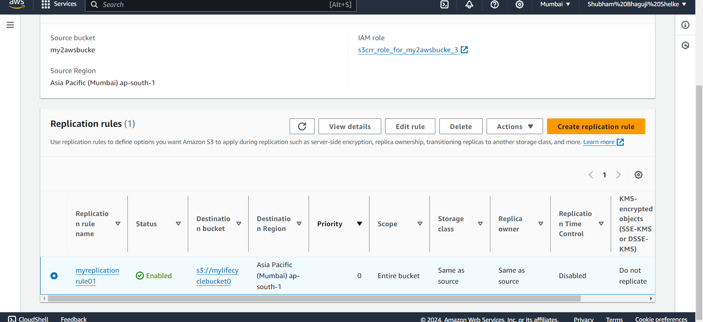

**We have created two users with S3ReadOnlyFullAccess policy**

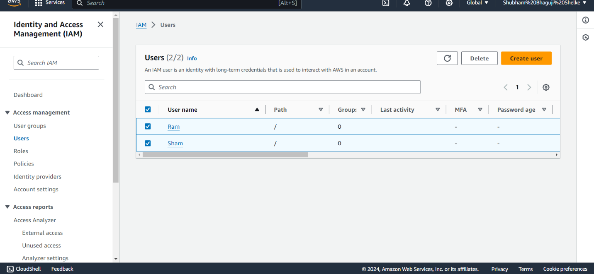

**Created one normal bucket**

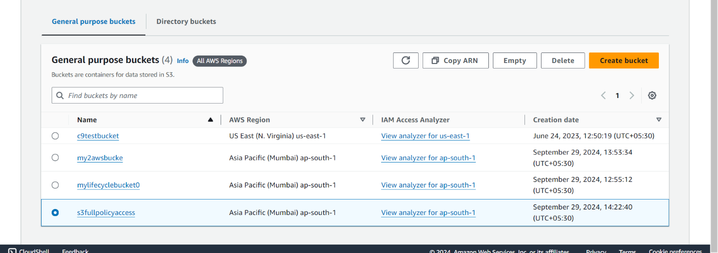

**Go to bucket policy and clicked on edit button it will open below page then click on policy generator**

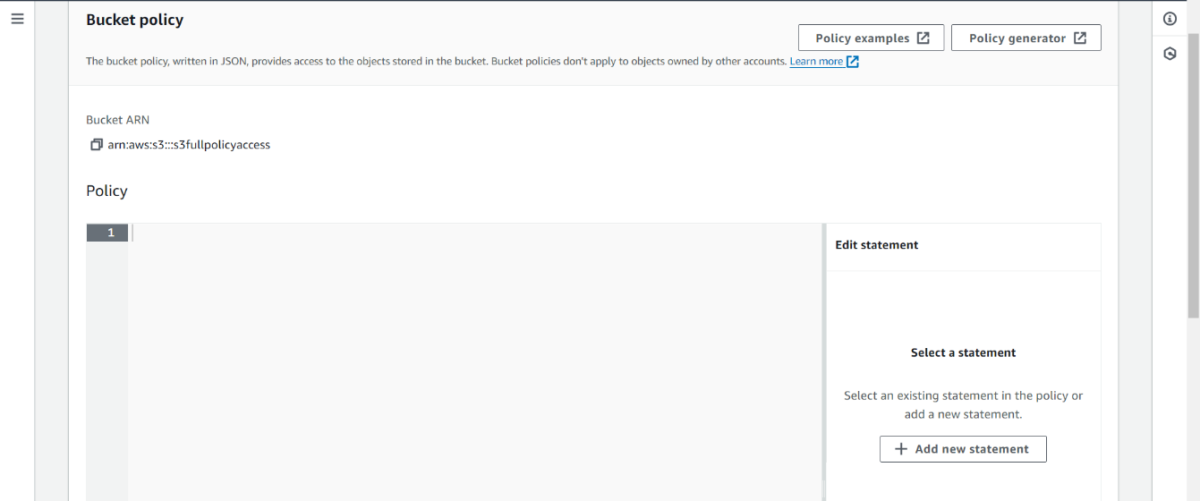

**We have provide policy for Ram user it will generate**

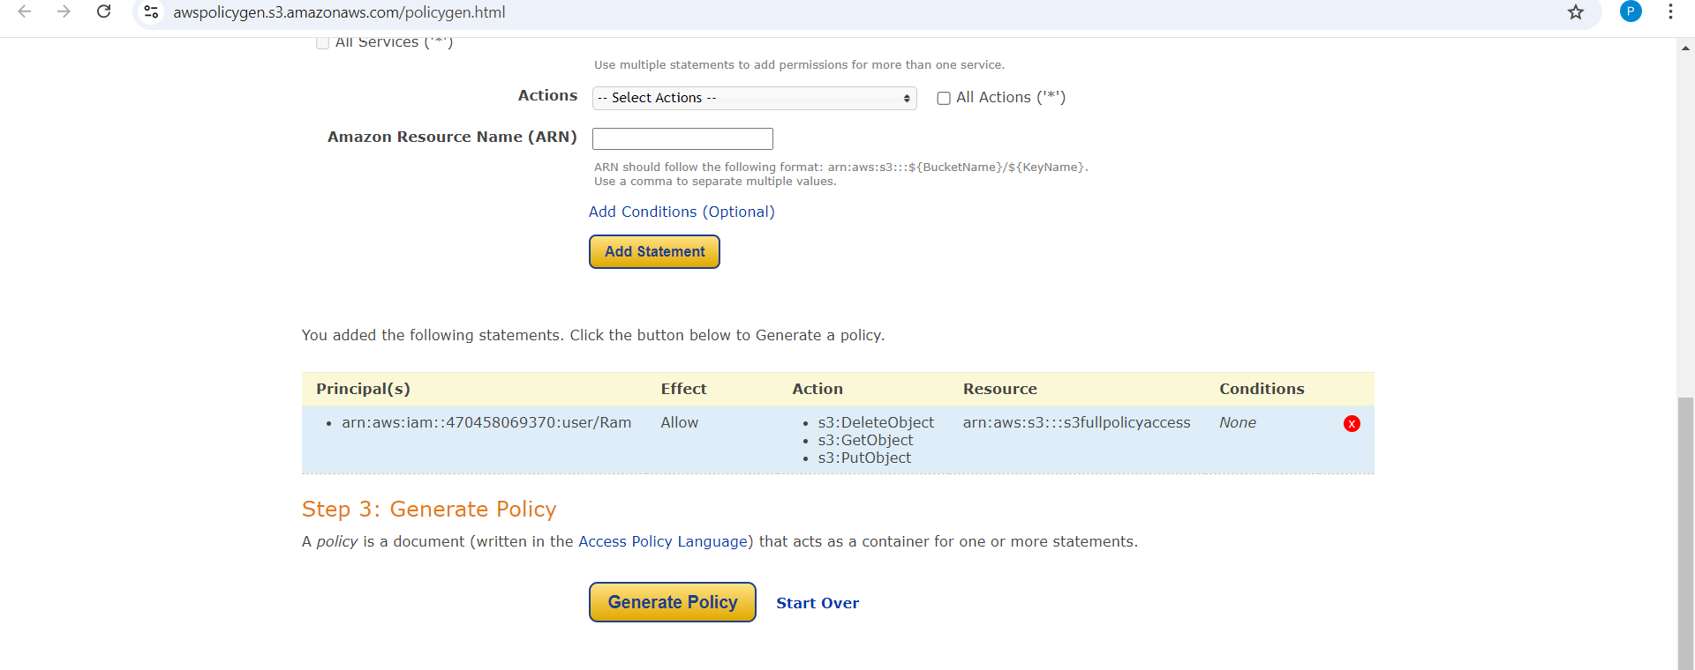

**Policy has been generated**

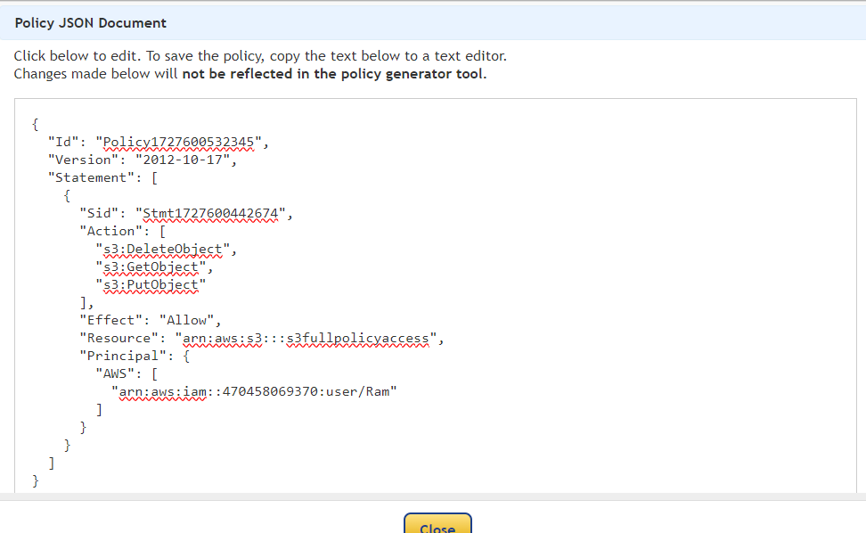

**Paste the code in bucket and click on save changes**

